**Project Synergy – Final Report**

Ayan Farah, Mahad Farah, Evan Preston

4/29/2023

**Executive Summary**

Project Synergy is a systems design project for the University of Minnesota Duluth Athletics Department with the goal to design an enhanced and synergetic inventory system. Currently the UMD Athletics department does not have any sort of inventory management system in place, leading to clutter, disorganization and prone to user error when it comes to reporting current inventory and ordering new equipment. UMD Athletics has reported problems with overbuying and underbuying equipment and is looking to improve their current situation. This report dives into the design of an inventory management system with capabilities to based on the sport: add new inventory, modify current inventory, the ability to produce a cost report based on current inventory and prices, and a log report to show version history of any changes that may need to be reverted. We expect this integrated system to lead to improved productivity and enhanced user experience and reduce risks of surplus or shortage when ordering equipment. Implementation of this system is also expected to reduce costs due to the increase in inventory management. Based on costs to implement the system and the costs saved by using this system we expect to have a ROI of 19.6% and expect to break even on this system in 1.55 years. In the rest of this document you will find all of the design specifications, diagrams, benefits and more to fully design this inventory system for UMD Athletics if you choose to develop this system in the future

Table of Contents

Project Vision1

Client Chart1

Problem/Opportunity Statement1

Business Value1

Business Requirements1

Special Issues or Constraints2

Project Scope3

Project Management Feasibility Report4

Technical Feasibility Analysis4

Operational/Cultural Feasibility Analysis4

Economic Feasibility5

Benefits5

Development Costs5

Operating Costs5

NPV Table6

Project Schedule7

Activity Diagrams8

Activity Diagram8

Activity Diagram Narrative9

Use Case Diagram10

Inventory Management Subsystem10

Version Control Log Subsystem11

Administrator Sybsystem12

Use Case Description13

Final Class Diagram15

Activity Diagram for Key Class Operations16

View Item Activity Diagram16

Add Item Activity Diagram 17

Delete Item Activity Diagram 18

Cost Report Activity Diagram 19

Log Report Activity Diagram 20

Sequence Diagrams21

View Item Sequence Diagram21

Add Item Sequence Diagram 22

Delete Item Sequence Diagram 23

Cost Report Sequence Diagram 24

Log Report Sequence Diagram 25

GUI Hierarchy Chart26

Prototype Screenshots27

Main Menu27

Sport Select Inventory28

Inventory Manage29

Log Report for Sports30

Log Report31

Cost Report for Sports32

Cost Report33

Risk Management Plan34

Testing Plan35

**Client chart**



**Problem/Opportunity statement**

**Introduction**

We will improve the experience of keeping track of sports equipment and clothing for the UMD Athletics Department. Our product will improve the experience for both the head coaches as well as the athletic directors as they will have a solution to knowing when sports equipment will have to be ordered based on the log of equipment the sport’s team’s currently have.

**Current State**

The UMD Athletics Department currently struggles with managing the equipment needed by the UMD sports teams. Currently there is no system in place to keep track of what equipment the teams currently have, what equipment needs to be ordered for the following season, and what equipment is expiring or being recalled.

**Impact**

As a result the athletic department has to do a full scale inventory every year in order to know what equipment is currently in use. There are occasionally errors which can cause a financial loss due to over ordering equipment.

Additionally, the athletic department relies on many different spreadsheets to keep track of all of this stuff in order to run reports. This system is unreliable and difficult to manage as you have to manually send the data through static files individually to whomever needs to data.

**Desired State**

The UMD athletics department would like to have a centralized application that can keep track of the equipment currently in use, allow coaches or equipment managers to add new items to the inventory, notify purchasers when equipment is expired or recalled, and to report when and what items need to be ordered.

**Conclusion**

As you can see, this Opportunity Statement makes it clear to all what the problem is, how it negatively impacts the workplace in multiple ways, and what the ideal situation would look once corrected.

**Business Value**

We expect this integrated system to lead to improved productivity and enhanced user experience and reduce risks of surplus or shortage when ordering equipment. Implementation of this system is also expected to reduce costs due to the increase in inventory management.

Reduction in time spent on inventory will save $200

Reduction in time spent on generating reports save $80

Reduced inventory Cost by $2,450.44

**Business Requirements**

* Be able to Monitor and record current inventory
* Ability to have anyone modify inventory whether it’s adding new/existing equipment or removing equipment
* Logging system to know who modified the inventory

**Special Issues or Constraints**

* Application must be compatible with current University of Minnesota Systems
* Must be able to be used by all UMD head coaches/equipment managers
* Coaches/equipment managers must be able to see only the sports they coach/manage
* Equipment directors must be able to view, add, delete, and run reports for all UMD sports

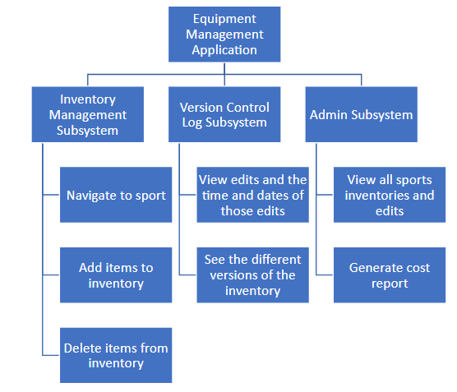

**Technical Feasibility Analysis**

This is possible using the following technologies:

**MS Access**

Inventory Management Database System can be created using MS Access which is a free software that is offered here at UMD.

MS Access can directly work with a website which allows for UMD to create a domain of this database for easy (permissible) access

**SQL Server**

ITSS will be able to backup the Inventory Management Database into a SQL Server.

Risks:

* System Crash
  + Database will have hourly backups and we will log every query so previous saves and edited work can be resubmitted.
  + This isn’t necessarily the database causing the issue, it is most likely a network issue.

**Operational/Cultural Feasibility Analysis**

The UMD Athletic staff are excited about this project, as an inventory management database will allow for time to be saved from for key athletics staff.

Athlete safety in UMD Sports is the top priority, a system like this will spot expired equipment due to easy access of information. It provides value from the original method that would require an extreme amount of human effort to manage inventory manually. The implementation of a database is not an if, but a when.

This database will boost staff moral due to the elimination of tiring and repetitive tasks decreasing.

Time saved will create ease of burden ship from staff that originally had to manually input inventory information.

**Benefits:** (These are long term investment returns that are gained back over time.)

· Reduction in Time Spent on Inventory: $200

o   Calculated using athletics trainer’s salary and time originally spent on inventory to projected time using inventory database.

o  

· Reduction in Time spent on Generating Reports: $80

o   Navigating and generating a report only takes approximately less than 5 minutes to create, meaning that if Director Berlo generates 2 reports for each sport per season, it will save $80 worth of salary per year.

o   Salary of UMD Athletics Director

o  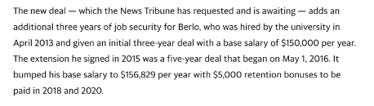

· Reduced Inventory Cost: $2,450.44

O The cost of every equipment within a sport(volleyball) summed up. The average of this is multiplied across all 6 UMD sports, totaling $2450.44.

**Development Costs:** (These are one time costs that will be incurred at the beginning of the process of building the inventory database.)

* Development Costs-$3600
  + Development Team Salaries: $3600
  + MS Access Software: $0
  + Development
    - Avg cost/employee: $30 per hour
    - Length of development: 3 weeks

**Operating Costs:** (These are on-going tangible costs that are needed to operate the system)

* Operational Labor: $100
* One-Time Training Cost: $50

**NPV Table**

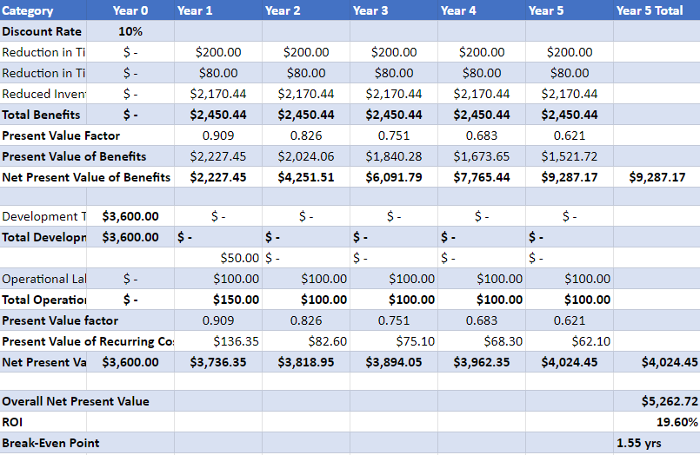





The interactions between the administrator and the system are depicted in this activity diagram. The activity diagram for the UMD athletic department inventory tracking system indicates that the administrator typically enters information about an item they want to add to the inventory or chooses an item they want to remove. The system will then add or remove the item from the inventory. If any modifications are made to the inventory, the system can also update it. All the administrator needs to do is check to see if the item has been deleted or added to the inventory. If an administrator wants to make a log report, all they have to do is click on the log report button, and the system will display the log report and the administrator will be able to print it. Finally, if an administrator wants to make a cost report for how much the volleyball team's equipment costs, they may do so by selecting the generate cost option and then selecting the volleyball team, and the system will display the cost of the equipment.







1. **As a Director of Athletics, I want to be able to use an inventory tracking system so I know what and how many items I have and should be ordering.**
   1. ***Log into system***
      1. **Coach or sports director shall be able to log into the system.**
         1. **System shall be capable of receiving UMD credentials.**
   2. ***Add items to inventory***
      1. **Coach or activity director shall be able to add items to the virtual inventory list**
         1. **The electronic inventory shall update when the coach or activity director presses a plus on the GUI.**
   3. ***Delete items from inventory***
      1. **Coach or activity director shall be able to delete items from the virtual inventory list**
         1. **The electronic inventory shall update when the coach or activity director presses a minus on the GUI.**
2. **As a Director of Athletics, I want to be able to have the system log edits so that edits are tracked in inventory.**
   1. ***View edits and metadata***
      1. **The sports director and/or the specific sport’s admin shall be able to view a list of edits and metadata of those edits.**
         1. **System shall automatically log all edits done in the GUI.**
   2. ***View inventory versions***
      1. **The sports director shall be able to see past and current versions of the inventories.**
         1. **The system shall cache past versions of the report after every edit is made**
   3. ***Generate log reports***
      1. **The sports director and/or the specific sport’s admin shall be able to generate a log report to track inventory activity over time.**
         1. **The metadata and specific edits shall be formatted into a report that can be generated upon request or automatically**
3. **As a Director of Athletics, I want to be able to have administrative control over the system so that I can monitor all sports’ inventories and generate cost reports.**
   1. ***Log into admin subsystem***
      1. **The Athletic Director shall be able to access the administrator view of the inventory system.**
         1. **System shall have a list of credentials that can be used to access the admin subsystem.**
   2. ***Adjust equipment prices***
      1. **The Athletic Director shall be able to update the price of the equipment** 
         1. **System shall support the option for admins to change prices**
   3. ***View inventories for all sports***
      1. **The athletic director shall be able to view inventories for all sports**
         1. **System shall contain an interface where all sports’ inventories are available.**
   4. ***Generate inventory cost report***
      1. **The athletic director shall be able to generate an inventory cost report for all sports**
         1. **Reports shall keep a running total of sports equipment that sorts by their respective sports**























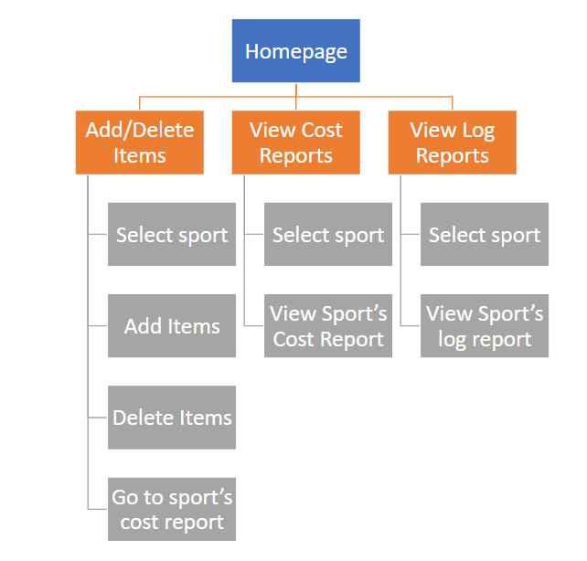

**Final list of prototype screens**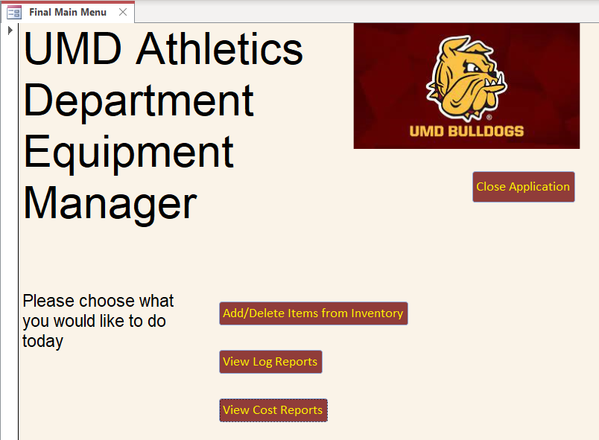

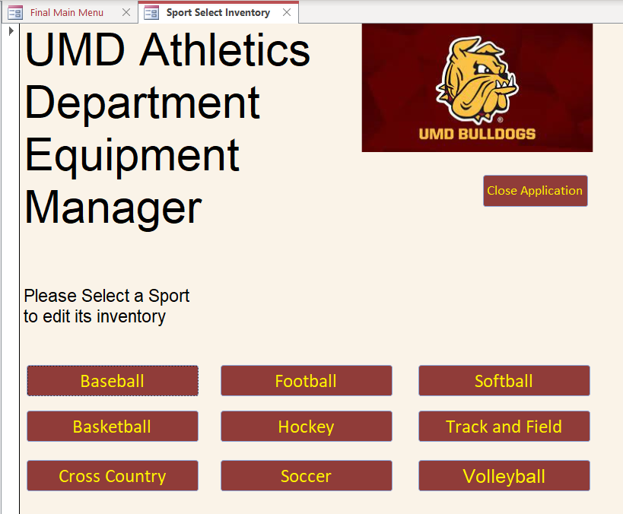

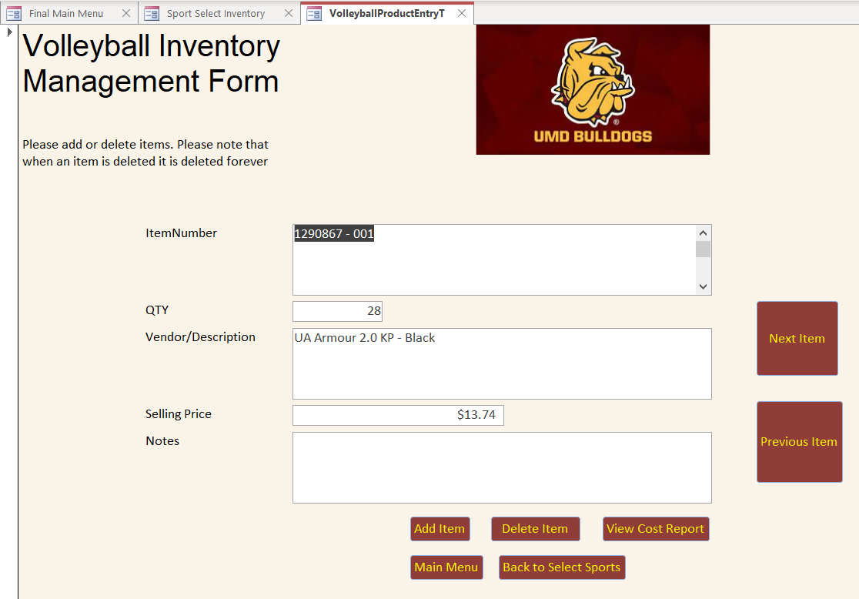

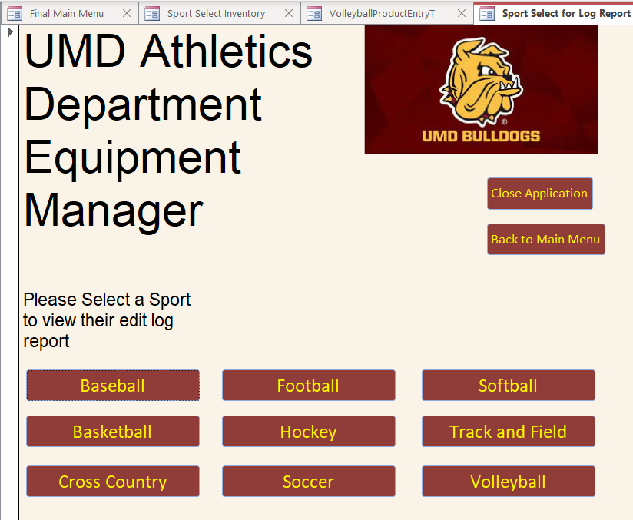

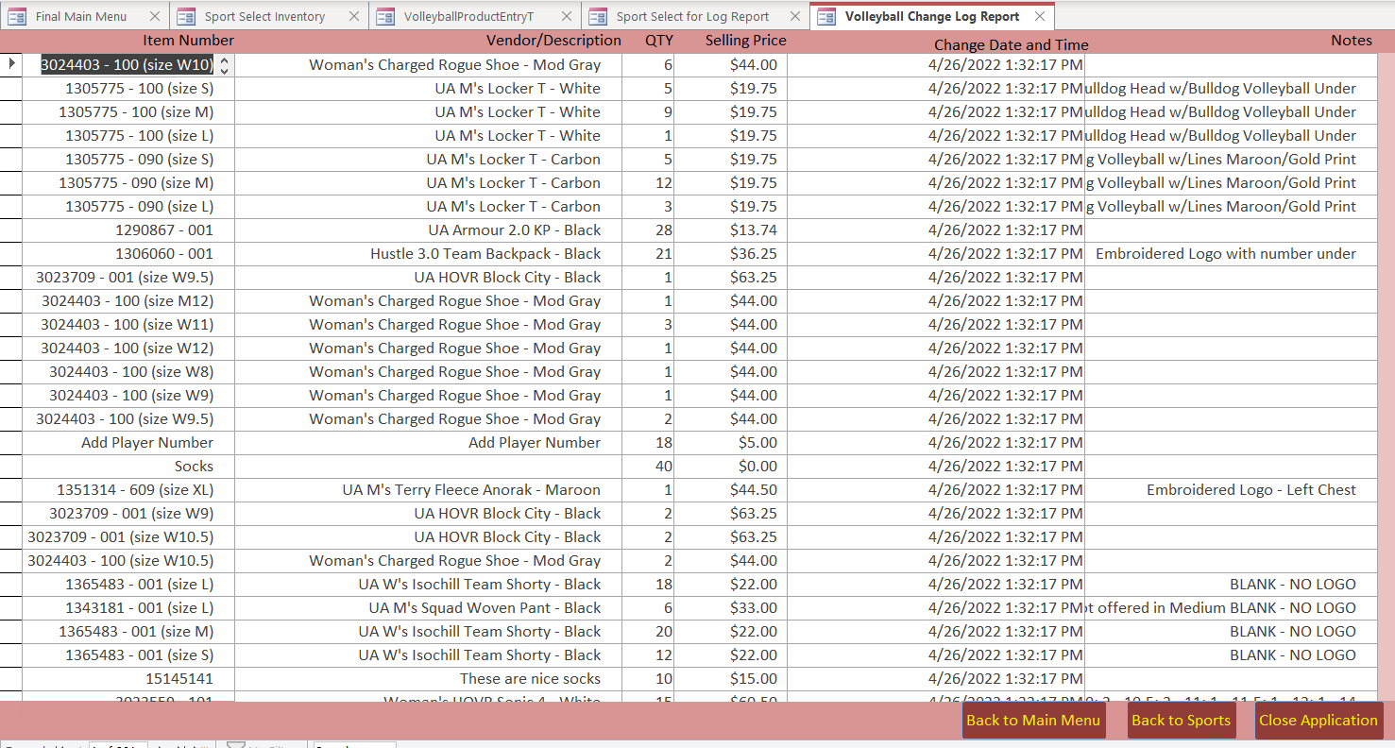

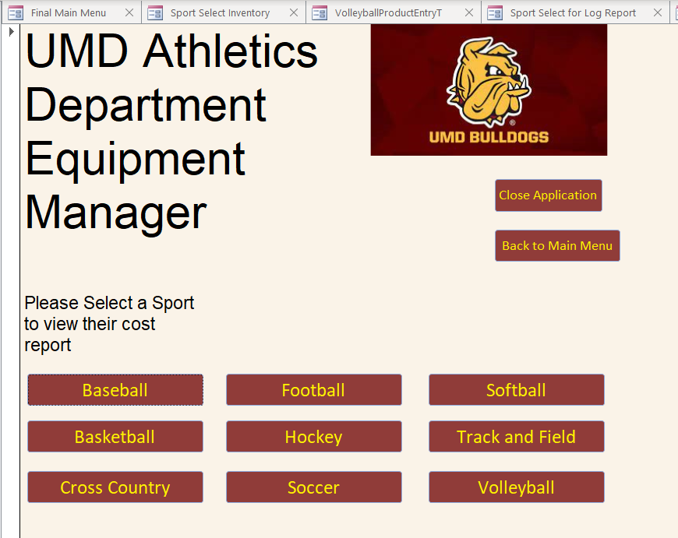

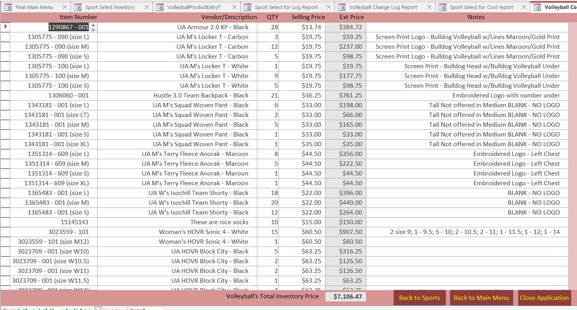

**Risk Identification**

|  |  |
| --- | --- |
| **RISK OVERVIEW** | **EVENT OR THREAT TRIGGERS** |
| 1. The loss of data from database. | System crash |
| 1. The amount of time spent on the project can affect the budget. Our project deadline is set to 3 weeks; however, this can be subject to change. | Time/Budget |
| 1. Scope Creep | Changing requirements |

**Mitigation**

|  |  |  |
| --- | --- | --- |
| **IDENTIFIED RISK** | 1. | **Loss of data** |
| **PROPOSED MITIGATION ACTION** | The best way to mitigate this risk is to have a consistent backup to protect the data. ITSS will be able to have a SQL server to backup the Inventory Management database. | |
| **IDENTIFIED RISK** | 2. | **Time/Budget** |
| **PROPOSED MITIGATION ACTION** | The best way to mitigate this risk Is to make sure that the requirements are understood before the start of this project. | |
| **IDENTIFIED RISK** | 3. | **Scope Creep** |
| **PROPOSED MITIGATION ACTION** | The best way to mitigate this risk is to consistently have meetings, and communication with the client will also mitigate the risk of going over schedule time which could affect the budget. | |

# **Integration Testing**

The codebase will implement Unit Testing to ensure the integrity of the platform.

# **Sample Test Data**

Add Item

* Item Number
  + 1290867 – 001
* Quantity
  + 28
* Vendor/Description
  + UA Armour 2.0 KP - Black
* Selling Price
  + 13.74
* Notes

Add Item

* Item Number
  + 1290867 – 002
* Quantity
  + 28
* Vendor/Description
  + UA Armour 2.0 KP - Black
* Selling Price
  + 13.74
* Notes

Delete Item

* Item Number
  + 1290867 – 002